Practical : 1
Aim: Perform SQL Queries With Aggregate Functions.
- List the details of the employee.

Query: select * from emp;
Output:

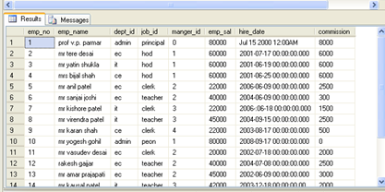

- Display the lowest, highest ,sum and average salary of all employee.

Query: select max(emp_sal)"MAX SAL",min(emp_sal)
"MIN SAL",SUM(emp_sal)"TOTAL" ,AVG(emp_sal)"AVG SAL" from emp;
Output:

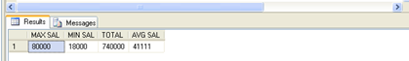

- Display the lowest,highest,sum and average salary of each department.

Query : select dept_id,max(emp_sal)"MAX SAL",min(emp_sal)"MIN SAL",SUM(emp_sal)"TOTAL" ,AVG(emp_sal)"AVG SAL" from emp group by dept_id;
Output:
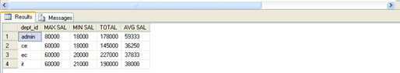

- Display the lowest,highest,sum and average salary of each job.

Query : select job_id,max(emp_sal)"MAX SAL",min(emp_sal)"MIN SAL",SUM(emp_sal)"TOTAL" ,AVG(emp_sal)"AVG SAL" from emp group by job_id;
Output:

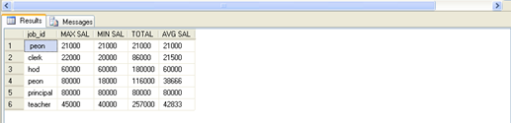

- Display the lowest,highest,sum and average salary of each job within each department.

Query : select job_id,dept_id,max(emp_sal)"MAX SAL",min(emp_sal)
"MIN SAL",SUM(emp_sal)"TOTAL" ,AVG(emp_sal)"AVG SAL" from emp group by job_id,dept_id;
Output:

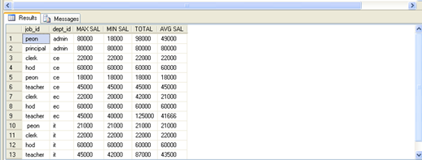

- Write a query to display the no. of people with the same job in each department.

Query : select dept_id,job_id,count(*)from emp group by job_id,dept_id;
Output:
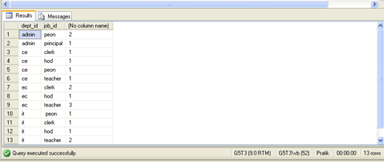

- Write a query to display the no. of people with the same job in whole company.

Query : select job_id,count(*)"No Of People" from emp group by job_id;
Output:

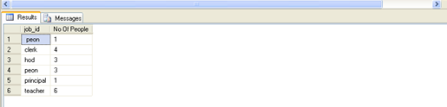

- Determine the no of department in company from employee table.

Query: select count(distinct(dept_id))"No Of Department" from emp;
Output:

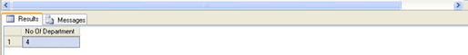

- Determine the no of manager without listing them.

Query: select count(*)"No Of Manager" from emp where job_Id = 'Manager';
Output:
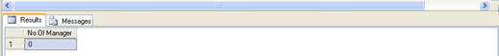

- Write a query that display the difference between the highest and the lowest salary.

Query: select max(emp_sal)"Maximum",min(emp_sal)"Minimum", max(emp_sal) - min(emp_sal) "Diff Between Highest and Lowest Salary" from emp;
Output:

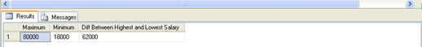

- Display manager number and the salary of lowest paid employee For the manager and sort the output in descending orders of the salary.

Query:- select manger_id,min(emp_sal)"Lowest paid Salary" from emp group by manger_id order by min(emp_sal) desc;
Output:

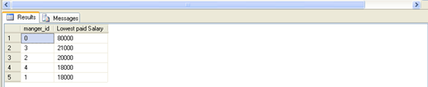

- Write query to display number of employee for each department.

Query: select dept_id,count(*)"No Of Employee" from emp group by dept_id;
Output:

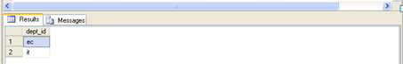

- Create a query that will display no of employee hired in each year.

Query: select year(hiredate),count(emp_no) from emp group by year(hiredate);
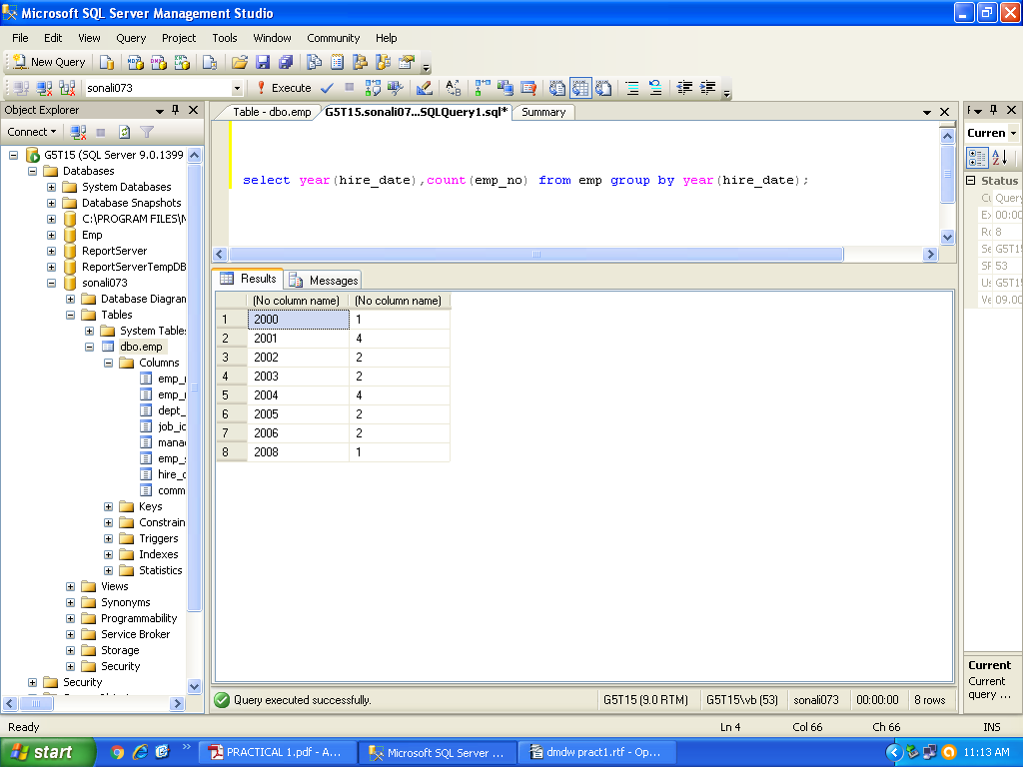
Output:
- Display only those department names which have no of employees greater than four.

Query: select dept_id from emp group by dept_id having count(*) > 4;
Output:

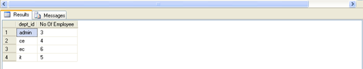

- Display the number of each employee in department IT who earned commission.

Query: select count(*)"No Of Employee" from emp where dept_id = 'it' and commision > 0;
Output:

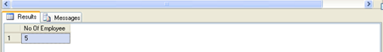

- Display average commission of employee for each department.

Query : select Dept_id,avg(commision)"Avg Commision" from emp group by dept_id;
Output:

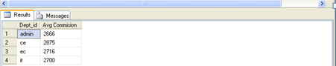

- Display total monthly salary for department where department monthly salary > 50000.

Query: select dept_id,max(emp_sal)"Maximum Salary" from emp where emp_sal > 50000 group by dept_id;
Output:

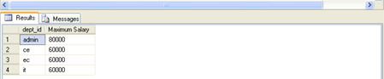

- Display maximum of department wise average salary.

Query: select top(1)max(avg(emp_sal))over()"Max Dept wise avg Salary" from emp group by dept_id;
Output:

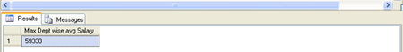

- Display employee whose job id is same as that of employee 2 and salary is greater that of employee.

Query: select emp_no from emp where job_id in (select job_id from emp where emp_no != 2 and emp_sal >(select emp_sal from emp where emp_no = 2))
Output:

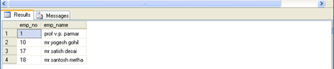

- Display the employee no and name of all employee whose salary is equal to minimum salary of the department IT.

Query: select emp_no,emp_name from emp where emp_sal =(select min(emp_sal) from emp where dept_id=’it’);
Output:

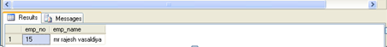

- Display name and salary of every employee who reports to Mr.Yatin Shukla.

Query: select emp_name, emp_sal from emp where manager_id =(select emp_no from emp where emp_no=3) and emp_name!=' mr yatin shukla';
Output:

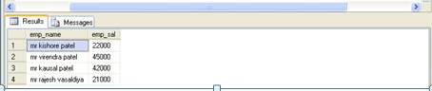

Practical : 2
Aim : Perform Rollup, Cube, Grouping And Grouping Sets Operations On 2- Dimensional Data.
- Display total salary for each job in each department using CUBE.
SQL> select dept_id,job_id,sum(sal) from emp_104 group by cube(dept_id,job_id);
DEPT_ID JOB_ID SUM(SAL)
---------- ---------- ----------
259000
Manager 150000
Designer 10000
Developer 85500
Accountant 7500
Developer 6000
6 38000
6 Manager 30000
6 Developer 8000
11 90500
11 Manager 50000

DEPT_ID JOB_ID SUM(SAL)
---------- ---------- ----------
11 Developer 33000
11 Accountant 7500
12 76000
12 Manager 25000
12 Designer 10000
12 Developer 35000
12 Developer 6000
18 54500
18 Manager 45000
18 Developer 9500
21 rows selected.
- Display total salary for each job in each department using ROLLUP.

SQL> select dept_id,job_id,sum(sal) from emp_104 group by rollup(job_id,dept_id);
DEPT_ID JOB_ID SUM(SAL)
---------- ---------- ----------
6 Manager 30000
11 Manager 50000
12 Manager 25000
18 Manager 45000
Manager 150000
12 Designer 10000
Designer 10000
6 Developer 8000
11 Developer 33000
12 Developer 35000
18 Developer 9500

DEPT_ID JOB_ID SUM(SAL)
---------- ---------- ----------
Developer 85500
11 Accountant 7500
Accountant 7500
12 Developer 6000
Developer 6000
259000
17 rows selected.
- GROUPING:

SQL> select job_id,dept_id,sum(sal),grouping(job_id) from emp_104 group by cube(job_id,dept_id);
JOB_ID DEPT_ID SUM(SAL) GROUPING(JOB_ID)
---------- ---------- ---------- ----------------
259000 1
6 38000 1
11 90500 1
12 76000 1
18 54500 1
Manager 150000 0
Manager 6 30000 0
Manager 11 50000 0
Manager 12 25000 0
Manager 18 45000 0
Designer 10000 0

JOB_ID DEPT_ID SUM(SAL) GROUPING(JOB_ID)
---------- ---------- ---------- ----------------
Designer 12 10000 0
Developer 85500 0
Developer 6 8000 0
Developer 11 33000 0
Developer 12 35000 0
Developer 18 9500 0
Accountant 7500 0
Accountant 11 7500 0
Developer 6000 0
Developer 12 6000 0
21 rows selected.
- GROUPING

SQL> select job_id, dept_id, sum(sal),grouping(job_id),grouping(dept_id) from emp_104 group by cube(j
ob_id, dept_id);
JOB_ID DEPT_ID SUM(SAL) GROUPING(JOB_ID) GROUPING(DEPT_ID)
---------- ---------- ---------- ---------------- -----------------
259000 1 1
6 38000 1 0
11 90500 1 0
12 76000 1 0
18 54500 1 0
Manager 150000 0 1
Manager 6 30000 0 0
Manager 11 50000 0 0
Manager 12 25000 0 0
Manager 18 45000 0 0
Designer 10000 0 1

JOB_ID DEPT_ID SUM(SAL) GROUPING(JOB_ID) GROUPING(DEPT_ID)
---------- ---------- ---------- ---------------- -----------------
Designer 12 10000 0 0
Developer 85500 0 1
Developer 6 8000 0 0
Developer 11 33000 0 0
Developer 12 35000 0 0
Developer 18 9500 0 0
Accountant 7500 0 1
Accountant 11 7500 0 0
Developer 6000 0 1
Developer 12 6000 0 0
21 rows selected.

- GROUPING_ID

SQL> select job_id,dept_id,sum(sal),grouping_id(job_id,dept_id) from emp_104 group by cube(job_id,dept_id);
JOB_ID DEPT_ID SUM(SAL) GROUPING_ID(JOB_ID,DEPT_ID)
---------- ---------- ---------- ---------------------------
259000 3
6 38000 2
11 90500 2
12 76000 2
18 54500 2
Manager 150000 1
Manager 6 30000 0
Manager 11 50000 0
Manager 12 25000 0
Manager 18 45000 0
Designer 10000 1

JOB_ID DEPT_ID SUM(SAL) GROUPING_ID(JOB_ID,DEPT_ID)
---------- ---------- ---------- ---------------------------
Designer 12 10000 0
Developer 85500 1
Developer 6 8000 0
Developer 11 33000 0
Developer 12 35000 0
Developer 18 9500 0
Accountant 7500 1
Accountant 11 7500 0
Developer 6000 1
Developer 12 6000 0
21 rows selected.

- GROUPING SETS

Calculate salary of each group of job and department.
SQL> select job_id,dept_id,sum(sal) from emp_104 group by grouping sets(job_id,dept_id);
JOB_ID DEPT_ID SUM(SAL)
---------- ---------- ----------
Accountant 7500
Designer 10000
Developer 85500
Developer 6000
Manager 150000
6 38000
11 90500
12 76000
18 54500
9 rows selected.
- GROUPING SET WITH GROUPING

SQL> select job_id,dept_id,sum(sal),grouping(job_id) from emp_104 group by grouping sets(job_id,dept_id);
JOB_ID DEPT_ID SUM(SAL) GROUPING(JOB_ID)
---------- ---------- ---------- ----------------
Accountant 7500 0
Designer 10000 0
Developer 85500 0
Developer 6000 0
Manager 150000 0
6 38000 1
11 90500 1
12 76000 1
18 54500 1
9 rows selected.

Practical : 3
Aim : Overview Of SQL Server 2005 Analysis Services.
The online analytical processing (OLAP) and data mining tools are consolidated into two working environments: Business Intelligence Development Studio and SQL Server Management Studio. Using Business Intelligence Development Studio, you can develop an Analysis Services project disconnected from the server. When the project is ready, you can deploy it to the server. You can also work directly against the server. The main function of SQL Server Management Studio is to manage the server.
Business Intelligence Development Studio
Business Intelligence Development Studio is a set of tools designed for creating business intelligence projects. Because Business Intelligence Development Studio was created as an IDE environment in which you can create a complete solution, you work disconnected from the server. You can change your data mining objects as much as you want, but the changes are not reflected on the server until after you deploy the project.
Working in an IDE is beneficial for the following reasons:
- You have powerful customization tools available to configure Business Intelligence Development Studio to suit your needs.

- You can integrate your Analysis Services project with a variety of other business intelligence projects encapsulating your entire solution into a single view.

- Full source control integration enables your entire team to collaborate in creating a complete business intelligence solution.

The Analysis Services project is the entry point for a business intelligence solution. An Analysis Services project encapsulates mining models and OLAP cubes, along with supplemental objects that make up the Analysis Services database. From Business Intelligence Development Studio, you can create and edit Analysis Services objects within a project and deploy the project to the appropriate Analysis Services server or servers.
SQL Server Management Studio
After you have used BI Development Studio to build mining models for your data mining project, you can manage and work with the models and create predictions in Management Studio.
SQL Server Reporting Services
After you create a mining model, you may want to distribute the results to a wider audience. You can use Report Designer in Microsoft SQL Server 2005 Reporting Services (SSRS) to create reports, which you can use to present the information that a mining model contains. You can use the result of any DMX query as the basis of a report, and can take advantage of the parameterization and formatting features that are available in Reporting Services

Microsoft SQL Server 2005 Analysis Services (SSAS)
Microsoft SQL Server 2005 Analysis Services (SSAS) provides both online analytical processing (OLAP) and data mining functionality for use in business intelligence applications. Analysis Services supports OLAP by allowing you to design, create, and manage multidimensional structures that contain data aggregated from other data sources, such as relational databases. For data mining applications, Analysis Services allows you to use a variety of industry-standard data mining algorithms to design, create, and visualize data mining models based on other data sources. Alternatively, you can create your own data mining algorithms; these algorithms can be plugged into SQL Server and made available to your developers and customers.
The following list of key topics explain about how to understand and use Analysis Services.
- Analysis Services Concepts and Objects
- Introduction to Cubes (SSAS)
- Data Mining Concepts

Analysis Services Concepts and Objects
Microsoft SQL Server 2005 Analysis Services (SSAS) delivers online analytical processing (OLAP) and data mining functionality through a combination of server and client technologies, further reinforced through the use of a specialized development and management environment coupled with a well-defined object model for designing, creating, deploying, and maintaining business intelligence applications.
Analysis Services Architecture
Microsoft SQL Server 2005 Analysis Services (SSAS) uses both server and client components to supply online analytical processing (OLAP) and data mining functionality for business intelligence applications:
- The server component of Analysis Services is implemented as a Microsoft Windows service. SQL Server 2005 Analysis Services supports multiple instances on the same computer, with each instance of Analysis Services implemented as a separate instance of the Windows service.
- Clients communicate with Analysis Services using the public standard XMLfor Analysis (XMLA), a SOAP-based protocol for issuing commands and receiving responses, exposed as a web service. In addition, client object models are provided over XMLA, including both a managed provider (ADOMD.Net) and a native OLE DB provider.
- Query commands can be issued using: SQL; Multidimensional Expressions (MDX), an industry standard query language orientated towards analysis; or Data Mining Extensions (DMX), an industry standard query language oriented toward data mining. Analysis Services Scripting Language (ASSL) can also be used to manage Analysis Services database objects. For more information, see Analysis Services Scripting Language (ASSL)
Analysis Services also supports a local cube engine that allows applications on disconnected clients to browse locally stored multidimensional data.
Server Architecture (SSAS)
The server component of Analysis Services is the msmdsvr.exe application, which normally runs as a Windows service. This application consists of an XML/A listener component and numerous internal components that perform the following functions:
- Parse statements received from clients
- Management meta data
- Handle transactions
- Process calculations
- Store dimension and cell data
- Create aggregations
- Schedule queries
- Caching objects
- Manage server resources
XML/A Listener
The XMLA listener component handles all XMLA communications between Analysis Services and its clients. The Analysis Services Port configuration setting can be used to specify a port on which an Analysis Services instance listens. Unless otherwise specified, Analysis Services uses the following default TCP ports:
Port | Description
2725 | Existing Microsoft SQL Server 2000 Analysis Services instances.
2383 | Microsoft SQL Server 2005 Analysis Services default instance.
2382 | Redirector for other Microsoft SQL Server 2005 Analysis Services instances.

Client Architecture (SSAS)

Microsoft SQL Server 2005 Analysis Services (SSAS) supports a thin client architecture. The Analysis

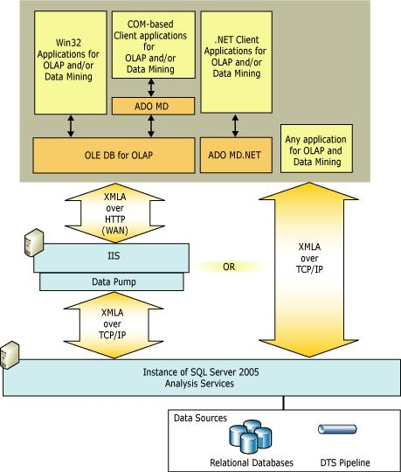

Services calculation engine is entirely server-based, so all queries are resolved on the server. As a result, only a single round trip between the client and the server is required for each query, resulting in scalable performance as queries increase in complexity.
The native protocol for Analysis Services is XML for Analysis (XML/A). Analysis Services provides several data access interfaces for client applications, but all of these components communicate with an instance of Analysis Services using XML for Analysis.
Several different providers are provided with Analysis Services to support different programming languages. A provider communicates with an Analysis Services server by sending and receiving XML for Analysis in SOAP packets over TCP/IP or over HTTP through Internet Information Services (IIS). An HTTP connection uses a COM object instantiated by IIS, called a data pump, which acts as conduit for Analysis Services data. The data pump does not examine the underlying data contained in the HTTP stream in any way, nor are any of the underlying data structures available to any of the code in the data library itself.
Win32 client applications can connect to an Analysis Services server using OLE DB for OLAP interfaces or the Microsoft® ActiveX® Data Objects (ADO) object model for Component Object Model (COM) automation languages, such as Microsoft Visual Basic®. Applications coded with .NET languages can connect to an Analysis Services server using ADO MD.NET.
Existing applications can communicate with Analysis Services without modification simply by using one of the Analysis Services providers.
Programming Language | Data Access Interface
C++ | OLE DB for OLAP
Visual Basic 6 | ADO MD
.NET languages | ADO MD.Net
Any language that supports SOAP | XML for Analysis

Analysis Services has a Web architecture with a fully scalable middle tier for deployment by both small and large organizations. Analysis Services provides broad middle tier support for Web services. ASP applications are supported by OLE DB for OLAP and ADO MD, ASP.NET applications are supported by ADOMD.NET. The middle tier, illustrated in the following figure, is scalable to many concurrent users.

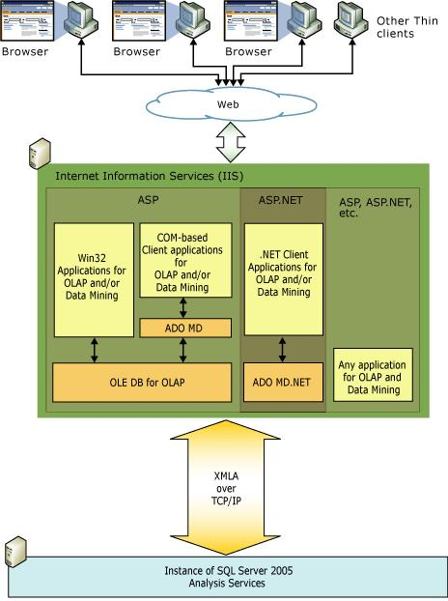

Analysis Services Concepts (SSAS)
Microsoft SQL Server 2005 Analysis Services (SSAS) provides online analytical processing (OLAP) and data mining functionality for business intelligence solutions. Before designing a business intelligence solution using Analysis Services, you should familiarize yourself with the OLAP and data mining concepts required for a successful solution.
Analysis Services combines the best aspects of traditional OLAP-based analysis and relational-based reporting by enabling developers to define a single data model, called a Unified Dimensional Model (UDM) over one or more physical data sources. All end user queries from OLAP, reporting, and custom BI applications access the data in the underlying data sources through the UDM, which provides a single business view of this relational data.
Analysis Services provides a rich set of data mining algorithms to enable business users to mine their data looking for specific patterns and trends. These data mining algorithms can be used to analyze data through a UDM or directly from a physical data store.
The role of a Unified Dimensional Model (UDM) is to provide a bridge between the user and the data sources. A UDM is constructed over one or more physical data sources, and then the end user issues
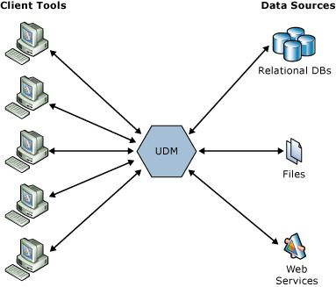

queries against the UDM using one of a variety of client tools, such as Microsoft Excel.
The UDM provides the following benefits:
- Allows the user model to be greatly enriched.
- Provides high performance queries supporting interactive analysis, even over huge data volumes.
- Allows business rules to be captured in the model to support richer analysis.
- Supports „closing the loop‟, where the user acts upon the data they see.

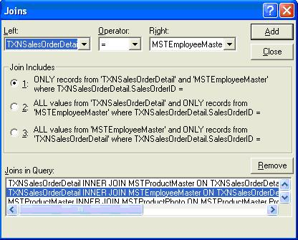
Accessing the Data Sources Directly

First, consider the case where the end user accesses the data sources directly. An example of a query being constructed using a sample tool is shown in the above illustration
By this point, the user has made considerable progress. They have:

- Sifted through the large number of cryptically named tables to find the ones of interest.
- Identified which columns they think should be used to join the tables together.
- Selected those columns that contain the details of interest, often having to pull them out from a sea of system-orientated details. For example, among the 11 columns on the tables holding details of product categories, only the two name columns are actually relevant to a human.

The user is now engaged in defining where „outer‟ versus „inner‟ joins should be used, and how to group details to provide the required aggregates.
However, the worse is still to come. How to get data joined in from the other data source? Even if one of the databases supported distributed queries, it is well beyond most users to construct the required query, and tools generally fall shy of supporting the user in this.
However, the worse is still to come. How to get data joined in from the other data source? Even if one of the databases supported distributed queries, it is well beyond most users to construct the required query, and tools generally fall shy of supporting the user in this.
Then considering other data sources, such as web services, the user is presented with another huge hurdle in determining how to make the necessary remote calls, and process the returned XML to join it in with the other data.
Finally, once this work is done for one query (“show total sales and quotas by category”), much of it must be redone for the next query (“...now break it down by employee”), and every succeeding query.
Accessing via a UDM
By contrast, an example of how building a query would appear to an end-user accessing a simple UDM constructed over these data sources is shown below.
Both client and middle tier applications can communicate directly with Analysis Services without using a provider. Client and middle tier applications may send XML for Analysis in SOAP packets over TCP/IP, HTTP, or HTTPS. The client may be coded using any language that supports SOAP. Communication in this case is most easily managed by Internet Information Services (IIS) using HTTP, although a direct connection to the server using TCP/IP may also be coded. This is the thinnest possible client solution for Analysis Services.

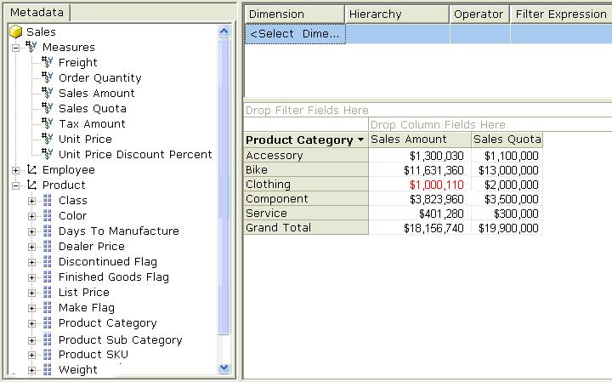

The tree view on the left presents the contents of the UD
The UDM also groups all attributes for each business entity (such as Product, or Employee) into separate „dimensions‟. The client could therefore refer to the Product Color, Subcategory, and Category in this example without explicitly performing joins between the numerous tables involved.
The UDM also groups all attributes for each business entity (such as Product, or Employee) into separate „dimensions‟. The client could therefore refer to the Product Color, Subcategory, and Category in this example without explicitly performing joins between the numerous tables involved.
Those columns that represent transaction values, or measurements, which a user is commonly interested in aggregating (such as “Sales Amount” or “Quota), are then presented as „measures‟. This method of presenting the data, as „measures‟ and „dimensions‟, is what is known as Dimensional Modeling, and has been shown in the industry to be a successful model for end user understandability.
The right hand side of the diagram shows those elements included in the current query. In this case, to request “Sales Amount and Quota by Product Category,” the user defined the query simply by dragging the three relevant items from the tree view. There was no need for the user to specify any of the details necessary to actually access the two different data sources and perform the necessary joins between the many tables involved.

Analysis Services Objects (SSAS)

A Microsoft SQL Server 2005 Analysis Services (SSAS) instance contains database objects and assemblies for use with UDMs and data mining.
- Databases contain UDM and data mining objects, such as data sources, data source views, cubes, dimensions, mining structures, and roles.
- Assemblies contain user-defined functions that extend the functionality of the intrinsic functions provided with the Multidimensional Expressions (MDX) and Data Mining Extensions (DMX) languages.

The following topics describe objects shared by both OLAP and data mining features in Analysis Service

Topic | Description
DataSources | Describes a data source in Analysis Services.
(SSAS) | Describes a data source in Analysis Services.
DataSource | Describes a data source view, a relational schema and associated queries used to
Views (SSAS) | model one or more data sources, in Analysis Services.
 | Describes cubes and cube objects, including measures, measure groups, dimension
Cubes (SSAS) | usage relationships, calculations, key performance indicators, actions, translations,
 | partitions, and perspectives.
Dimensions | Describes dimensions, dimension types, dimension storage, and dimension objects,
(SSAS) | including attributes, attribute relationships, hierarchies, levels, and members.

Data Mining Concepts
Data mining is frequently described as "the process of extracting valid, authentic, and actionable information from large databases." In other words, data mining derives patterns and trends that exist in data. These patterns and trends can be collected together and defined as a mining model. Mining models can be applied to specific business scenarios, such as:

- Forecasting sales.
- Targeting mailings toward specific customers.
- Determining which products are likely to be sold together.
- Finding sequences in the order that customers add products to a shopping cart.

An important concept is that building a mining model is part of a larger process that includes everything from defining the basic problem that the model will solve, to deploying the model into a working environment. This process can be defined by using the following six basic steps:

- Defining the Problem

- Preparing Data

- Exploring Data

- Building Models

- Exploring and Validating Models

- Deploying and Updating Models

The following diagram describes | the relationships between each step in the process, and the
technologies in Microsoft SQL | Server 2005 that you can use to complete each step.

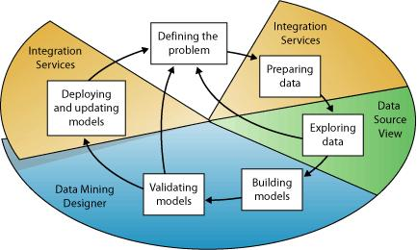

Although the process that is illustrated in the diagram is circular, each step does not necessarily lead directly to the next step. Creating a data mining model is a dynamic and iterative process. After you explore the data, you may find that the data is insufficient to create the appropriate mining models, and that you therefore have to look for more data. You may build several models and realize that they do not answer the problem posed when you defined the problem, and that you therefore must redefine the problem. You may have to update the models after they have been deployed because more data has become available. It is therefore important to understand that creating a data mining model is a process, and that each step in the process may be repeated as many times as needed to create a good model.
SQL Server 2005 provides an integrated environment for creating and working with data mining models, called Business Intelligence Development Studio. The environment includes data mining algorithms and tools that make it easy to build a comprehensive solution for a variety of projects. For more information about using BI Development Studio, see Developing Analysis Services Solutions and Projects (SSAS).
For more information about how to apply SQL Server tools to the business scenarios listed earlier in this topic, see Data Mining Tutorial.

Defining the Problem
The first step in the data mining process is to clearly define the business problem.
This step includes analyzing business requirements, defining the scope of the problem, defining the metrics by which the model will be evaluated, and defining the final objective for the data mining project. These tasks translate into questions such as the following:

- What are you looking for?

- Which attribute of the dataset do you want to try to predict?

- What types of relationships are you trying to find?

- Do you want to make predictions from the data mining model or just look for interesting patterns and associations?

- How is the data distributed?

- How are the columns related, or if there are multiple tables, how are the tables related?

To answer these questions, you may have to conduct a data availability study, to investigate the needs of the business users with regard to the available data. If the data does not support the needs of the users, you may have to redefine the project.
Preparing Data
The second step in the data mining process, is to consolidate and clean the data that was identified in the Defining the Problem step
Microsoft SQL Server 2005 Integration Services (SSIS) contains all the tools that you need to complete this step, including transforms to automate data cleaning and consolidation.
Data can be scattered across a company and stored in different formats, or may contain inconsistencies such as flawed or missing entries. For example, the data might show that a customer bought a product before that customer was actually even born, or that the customer shops regularly at a store located 2,000 miles from her home. Before you start to build models, you must fix these problems. Typically, you are working with a very large dataset and cannot look through every transaction. Therefore, you have to use some form of automation, such as in Integration Services, to explore the data and find the inconsistencies.
Exploring Data
The third step in the data mining process, is to explore the prepared that You must understand the data in order to make appropriate decisions when you create the models. Exploration techniques include calculating the minimum and maximum values, calculating mean and standard deviations, and looking at the distribution of the data. After you explore the data, you can decide if the dataset contains flawed data, and then you can devise a strategy for fixing the problems.
Data Source View Designer in BI Development Studio contains several tools that you can use to explore data.

Building Models
The fourth step in the data mining process, is to build the mining mode ls

Before you build a model, you must randomly separate the prepared data into separate training and testing datasets. You use the training dataset to build the model, and the testing dataset to test the accuracy of the model by creating prediction queries. You can use the Percentage Sampling Transformation in Integration Services to split the dataset.
You will use the knowledge that you gain from the Exploring Data step to help define and create a mining model. A model typically contains input columns, an identifying column, and a predictable column. You can then define these columns in a new model by using the Data Mining Extensions (DMX) language, or the Data Mining Wizard in BI Development Studio. For more information about how to use DMX, see Data Mining Extensions (DMX) Reference.
After you define the structure of the mining model, you process it, populating the empty structure with the patterns that describe the model. This is known as training the model. Patterns are found by passing the original data through a mathematical algorithm. SQL Server 2005 contains a different algorithm for each type of model that you can build. You can use parameters to adjust each algorithm.
A mining model is defined by a data mining structure object, a data mining model object, and a data mining algorithm.

Microsoft SQL Server 2005 Analysis Services (SSAS) includes the following algorithms:

- Microsoft Decision Trees Algorithm

- Microsoft Clustering Algorithm

- Microsoft Naive Bayes Algorithm

- Microsoft Association Algorithm

- Microsoft Sequence Clustering Algorithm

- Microsoft Time Series Algorithm

- Microsoft Neural Network Algorithm (SSAS)

- Microsoft Logistic Regression Algorithm

- Microsoft Linear Regression Algorithm

Exploring and Validating Models
The fifth step in the data mining process is to explore the models that you have built and test their effectiveness You do not want to deploy a model into a production environment without first testing how well the model performs. Also, you may have created several models and will have to decide which model will perform the best. If none of the models that you created in the Building Models step perform well, you may have to return to a previous step in the process, either by redefining the problem or by reinvestigating the data in the original dataset.
You can explore the trends and patterns that the algorithms discover by using the viewers in Data Mining Designer in BI Development Studio. You can also test how well the models create predictions by using tools in the designer such as the lift chart and classification matrix. These tools require the testing data that you separated from the original dataset in the model-building step.
Deploying and Updating Models
The last step in the data mining process, as highlighted in the following diagram, is to deploy to a production environment the models that performed the best.
After the mining models exist in a production environment, you can perform many tasks, depending on your needs. Following are some of the tasks you can perform:
- Use the models to create predictions, which you can then use to make business decisions. SQL Server provides the DMX language that you can use to create prediction queries, and Prediction Query Builder to help you build the queries.

- Embed data mining functionality directly into an application. You can include Analysis Management Objects (AMO) or an assembly that contains a set of objects that your application can use to create, alter, process, and delete mining structures and mining models. Alternatively, you can send XML for Analysis (XMLA) messages directly to an instance of Analysis Services.

- Use Integration Services to create a package in which a mining model is used to intelligently separate incoming data into multiple tables. For example, if a database is continually updated with potential customers, you could use a mining model together with Integration Services to split the incoming data into customers who are likely to purchase a product and customers who are likely to not purchase a product.

- Create a report that lets users directly query against an existing mining model.

Updating the model is part of the deployment strategy. As more data comes into the organization, you must reprocess the models, thereby improving their effectiveness.

Introduction to Cubes (SSAS)
A cube is defined by its measures and dimensions. The measures and dimensions in a cube are derived from tables and views in the data source view on which the cube is based. A cube consists of measures based on one or more fact tables and dimensions based on one or more dimension tables. Dimensions are based on attributes, which are mapped to one or columns in the dimension tables or views in the data source view, and then hierarchies are defined from these attributes.
Cube Example:
Consider the following Imports cube, which contains two measures, Packages and Last, and three related dimensions, Route, Source, and Time
The smaller alphanumeric values around the cube are the members of the dimensions. Example members are ground (member of the Route dimension), Africa (member of the Source dimension), and 1st quarter (member of the Time dimension).
Measures
The values within the cube represent the two measures, Packages and Last. The Packages measure represents the number of imported packages, and the Sum function is used to aggregate its facts. The Last measure represents the date of receipt, and the Max function is used to aggregate its facts.
Dimensions
The Route dimension represents the means by which the imports reach their destination. Members of this dimension include ground, nonground, air, sea, road or rail. The Source dimension represents the locations where the imports are produced, such as Africa or Asia. The Time dimension represents the quarters and halves of a single year.
Aggregates
Business users of a cube can determine its measures' values for each member of every dimension, regardless of the level of the member within the dimension, because Analysis Services aggregates values at upper levels as needed. For example, the measure values in the preceding illustration aggregate within a standard calendar hierarchy in the Time dimension as follows.
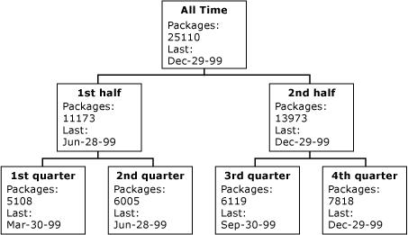

In addition to aggregating within a single dimension, measures aggregate for all combinations of members from different dimensions. This allows business users to evaluate measures by members in multiple dimensions simultaneously. For example, if a business user wants to analyze quarterly imports that arrived by air from the Eastern Hemisphere and Western Hemisphere, the business user can issue the appropriate query on the cube to retrieve the following dataset
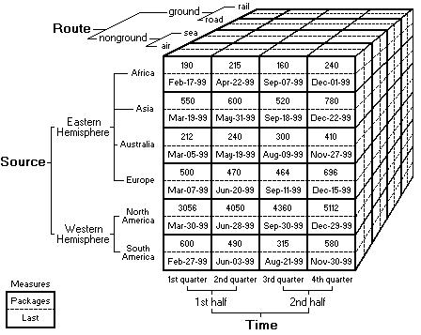
 |  |  | Packages |  | Last
 |  |  | All | Eastern | Western | All | Eastern | Western
 |  |  | Sources | Hemisphere | Hemisphere | Sources | Hemisphere | Hemisphere
All |  |  | 25110 | 6547 | 18563 | Dec-29- | Dec-22-99 | Dec-29-99
Time |  |  |  |  |  | 99
 | 1st |  | 11173 | 2977 | 8196 | Jun-28- | Jun-20-99 | Jun-28-99
 | half |  | 11173 | 2977 | 8196 | 99 | Jun-20-99 | Jun-28-99
 |  | 1st | 5108 | 1452 | 3656 | Mar-30- | Mar-19-99 | Mar-30-99
 |  | quarter |  |  |  | 99
 |  | 2nd | 6065 | 1525 | 4540 | Jun-28- | Jun-20-99 | Jun-28-99
 |  | quarter | 6065 | 1525 | 4540 | 99 | Jun-20-99 | Jun-28-99
 | 2nd |  | 13937 | 3570 | 10367 | Dec-29- | Dec-22-99 | Dec-29-99
 | half |  |  |  |  | 99
 |  | 3rd | 6119 | 1444 | 4675 | Sep-30- | Sep-18-99 | Sep-30-99
 |  | quarter |  |  |  | 99
 |  | 4th | 7818 | 2126 | 5692 | Dec-29- | Dec-22-99 | Dec-29-99
 |  | quarter |  |  |  | 99

After a cube is defined, aggregations can be defined to determine the extent to which aggregations are precalculated during processing versus calculated at query time.
Mapping Measures, Attributes, and Hierarchies
The cube's measures, attributes, and hierarchies are derived from the following columns in the cube's fact and dimension tables.
Measure or | Members | Source table | Source | Sample
attribute (level) | Members | Source table | column | column value
Packages measure | Not applicable | ImportsFactTable | Packages | 12
Last measure | Not applicable | ImportsFactTable | Last | May-03-99
Route Category |  |  | Route_Categ
level in Route | nonground,ground | RouteDimensionTable | Route_Categ | Nonground
dimension |  |  | ory
Route attribute in | air,sea,road,rail | RouteDimensionTable | Route | Sea
Route dimension
Hemisphere | Eastern |  |  | Eastern
attribute in | Hemisphere,Western | SourceDimensionTable | Hemisphere | Eastern
 |  |  |  | Hemisphere
Source dimension | Hemisphere |  |  | Hemisphere
Continent attribute | Africa,Asia,AustraliaEuro
in Source | Africa,Asia,AustraliaEuro | SourceDimensionTable | Continent | Europe
dimension | pe,N. America,S. America
Half attribute in | 1st half,2nd half | TimeDimensionTable | Half | 2nd half
Time dimension
Quarter attribute in | 1st quarter,2nd quarter,3rd | TimeDimensionTable | Quarter | 3rd quarter
Time dimension | quarter,4th quarter | TimeDimensionTable | Quarter | 3rd quarter

Data in a single cube cell is usually derived from multiple rows in the fact table. For example, the cell in the cube for the air member, the Africa member, and the 1st quarter member is derived from the following rows in the ImportsFactTable fact table.

Import_ReceiptKey | RouteKey | SourceKey | TimeKey | Packages | Last
3516987 | 1 | 6 | 1 | 15 | Jan-10-99
3554790 | 1 | 6 | 1 | 40 | Jan-19-99
3572673 | 1 | 6 | 1 | 34 | Jan-27-99
3600974 | 1 | 6 | 1 | 45 | Feb-02-99
3645541 | 1 | 6 | 1 | 20 | Feb-09-99
3674906 | 1 | 6 | 1 | 36 | Feb-17-99

In the preceding table, each row has the same values for the RouteKey, SourceKey, and TimeKey columns, indicating that these rows contribute to the same cube cell.
The example shown above was for a very simple cube, having a single measure group with all the dimension tables joined to it in a star schema. Another common schema is a snowflake schema, in which one or more dimension tables join to another dimension table rather than to the fact table.
The example shown above contains only a single fact table. When a cube has multiple fact tables, the measures from each fact table are organized into measure groups and a measure group is related to a specific set of dimensions by defined dimension relationships. These relationships specify the participating tables in the data source view and the granularity of the relationship.

Practical : 4
Aim : Design And Create Cube By Identifying Measures And Dimensions For Star Schema, Snowflake Schema.
Software Required: Analysis services- SQL Server-2005.
Knowledge Required: Data cube
Theory/Logic:
Creating a Data Cube
To build a new data cube using BIDS, you need to perform these steps:
- Create a new Analysis Services project
- Define a data source
- Define a data source view
- Invoke the Cube Wizard

We’ll look at each of these steps in turn.
Creating a New Analysis Services Project
To create a new Analysis Services project, you use the New Project dialog box in BIDS.
This is very similar to creating any other type of new project in Visual Studio.
To create a new Analysis Services project, follow these steps:
- Select Microsoft SQL Server 2005⇒ SQL Server Business Intelligence. Development Studio from the Programs menu to launch Business Intelligence Development Studio.
- Select File ⇒ New ⇒ Project.

- In the New Project dialog box, select the Business Intelligence Projects project type.

- Select the Analysis Services Project template.

- Name the new project AdventureWorksCube1 and select a convenient location to save it.
- Click OK to create the new project.

Defining a Data Source
To define a data source, you’ll use the Data Source Wizard. You can launch this wizard by

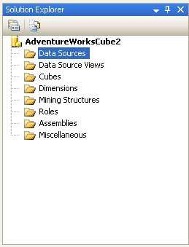

right-clicking on the Data Sources folder in your new Analysis Services project. The wizard will walk you through the process of defining a data source for your cube, including choosing a connection and specifying security credentials to be used to connect to the data source.
To define a data source for the new cube, follow these steps:
- Right-click on the Data Sources folder in Solution Explorer and select New Data Source.
Read the first page of the Data Source Wizard and click next.
- You can base a data source on a new or an existing connection. Because you don’t have any existing connections, click New.
- In the Connection Manager dialog box, select the server containing your analysis services sample database from the Server Name combo box.
Fill in your authentication information.
- Select the Native OLE DB\SQL Native Client provider (this is the default provider).
- Select the AdventureWorksDW database. Figure 3-2 shows the filled-in Click OK to dismiss the Connection Manager dialog box.
- Click Next.
Select Default impersonation information to use the credentials you just supplied for the connection and click Next.
Accept the default data source name and click Finish.
Connection Manager dialog box.

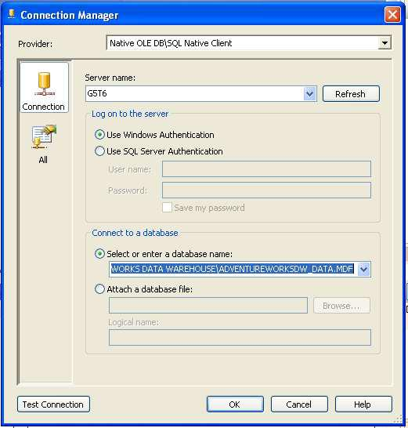

Defining a Data Source View
A data source view is a persistent set of tables from a data source that supply the data for a particular cube. BIDS also includes a wizard for creating data source views, which you can invoke by right-clicking on the Data Source Views folder in Solution Explorer.
To create a new data source view, follow these steps:
- Right-click on the Data Source Views folder in Solution Explorer and select New Data Source View.
- Read the first page of the Data Source View Wizard and click Next.
- Select the Adventure Works DW data source and click Next. Note that you could also launch the Data Source Wizard from here by clicking New Data Source.
- Select the dbo.FactFinance table in the Available Objects list and click the ⇒button to move it to the Included Object list. This will be the fact table in the new cube.
- Click the Add Related Tables button to automatically add all of the tables that are directly related to the dbo.FactFinance table. These will be the dimension tables for the new cube. Figure 2-3 shows the wizard with all of the tables selected.
- Click Next.
Name the new view Finance and click Finish. BIDS will automatically display the schema of the new data source view, as shown in Figure 2-4.

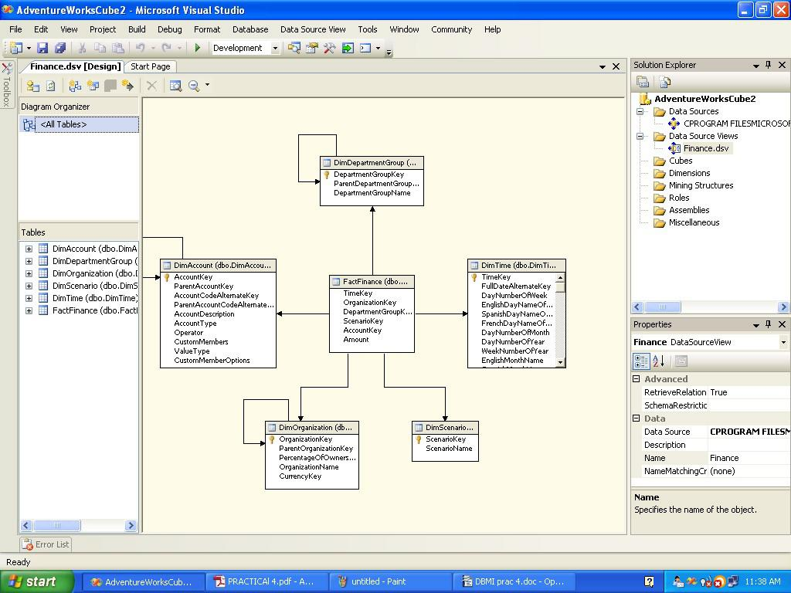
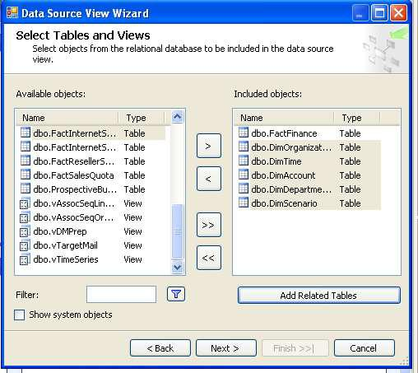
- Select the Finance data source view and click Next.
Wait for the Cube Wizard to analyze the data and then click Next.
The Wizard will get most of the analysis right, but you can fine-tune it a bit.Select DimTime in the Time Dimension combo box. Uncheck the Fact checkbox on the line for the dbo.DimTime table. This will allow you to analyze this dimension using standard time periods.
- Click Next.
- On the Select Time Periods page, use the combo boxes to match time property names to time columns according to Table 2-1.
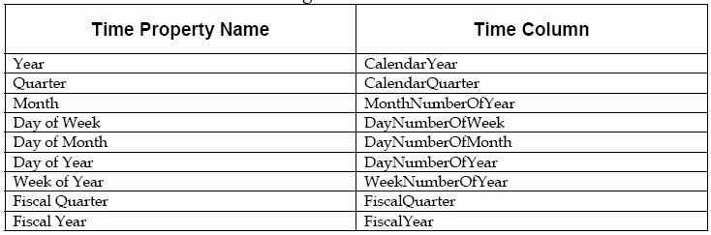

- Click Next.
- Accept the default measures and click Next.
- Wait for the Cube Wizard to detect hierarchies and then click Next.
- Accept the default dimension structure and click Next.
- Name the new cube FinanceCube and click Finish.

Deploying and Processing a Cube
At this point, you’ve defined the structure of the new cube - but there’s still more work to be done. You still need to deploy this structure to an Analysis Services server and then process the cube to create the aggregates that make querying fast and easy.
To deploy the cube you just created, select Build ⇒ Deploy AdventureWorksCube1.
This will deploy the cube to your local Analysis Server, and also process the cube, building the aggregates for you. BIDS will open the Deployment Progress window, as shown in Figure 2-5, to keep you informed during deployment and processing.

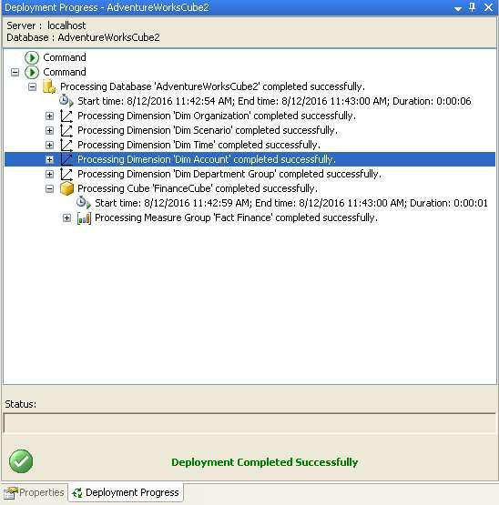

Exploring a Data Cube
At last you’re ready to see what all the work was for. BIDS includes a built-in Cube Browser that lets you interactively explore the data in any cube that has been deployed and processed. To open the Cube Browser, right-click on the cube in Solution Explorer and select Browse. Figure 2-6 shows the default state of the Cube Browser after it’s just been opened.
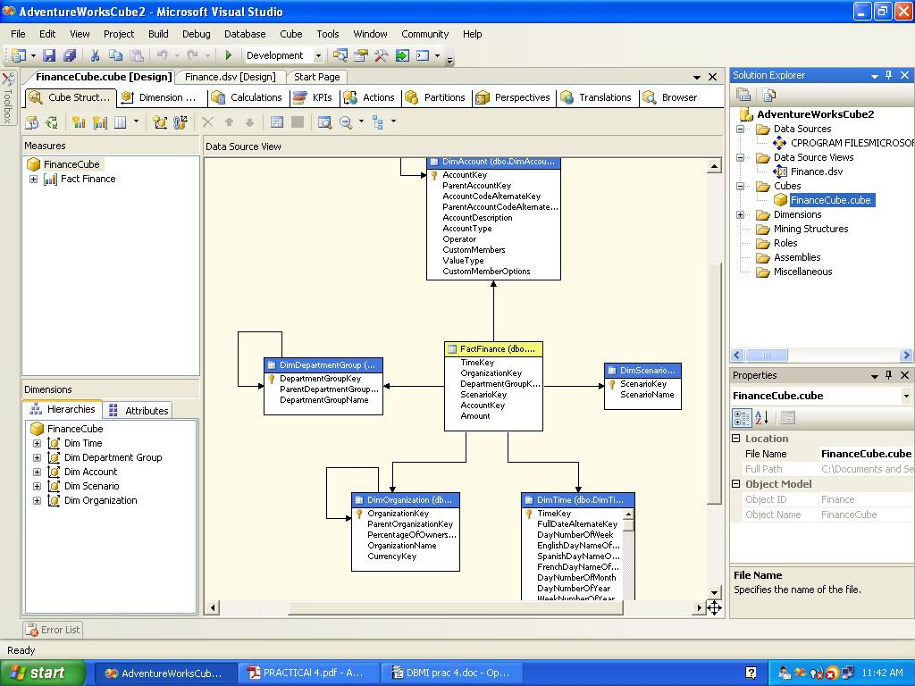
The Cube Browser is a drag-and-drop environment. If you’ve worked with pivot tables in Microsoft Excel, you should have no trouble using the Cube browser. The pane to the left includes all of the measures and dimensions in your cube, and the pane to the right gives you drop targets for these measures and dimensions. Among other operations, you can:

Drop a measure in the Totals/Detail area to see the aggregated data for that measure.
Drop a dimension or level in the Row Fields area to summarize by that level or dimension on rows.
Drop a dimension or level in the Column Fields area to summarize by that level or dimension on columns
Drop a dimension or level in the Filter Fields area to enable filtering by members of that dimension or level.
Use the controls at the top of the report area to select additional filtering expressions.
To see the data in the cube you just created, follow these steps:
Right-click on the cube in Solution Explorer and select Browse.
Expand the Measures node in the metadata panel (the area at the left of the user interface).
Expand the Fact Finance node.
Drag the Amount measure and drop it on the Totals/Detail area. Expand the Dim Account node in the metadata panel.
Drag the Account Description property and drop it on the Row Fields area. Expand the Dim Time node in the metadata panel.
Drag the Calendar Year-Calendar Quarter-Month Number of Year hierarchy and drop it on the Column Fields area.
Click the + sign next to year 2001 and then the + sign next to quarter 3. Expand the Dim Scenario node in the metadata panel.
Drag the Scenario Name property and drop it on the Filter Fields area.
Click the dropdown arrow next to scenario name. Uncheck all of the checkboxes except for the one next to the Budget name.
Figure 2-7 shows the result. The Cube Browser displays organization name and its account.
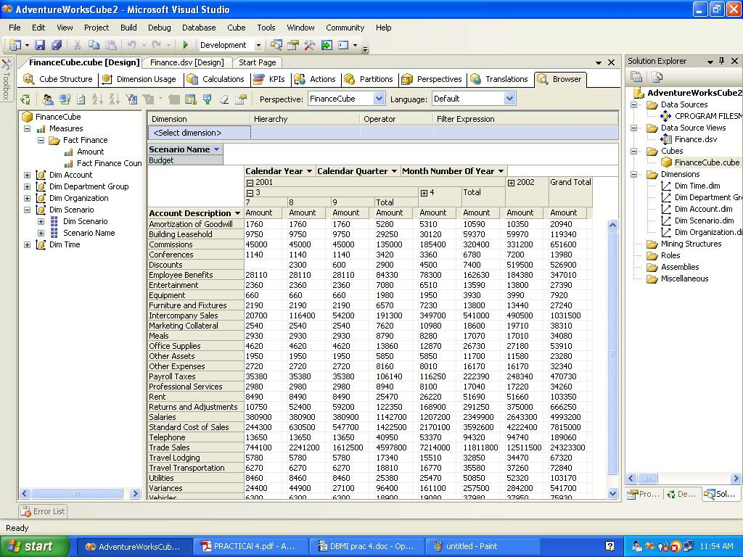

Practical : 6
Aim : Write a C program which implements “Data Cleaning” Smoothing by binning techniques mean, median and boundaries.
#include<stdio.h>
#include<conio.h>
#include<math.h>
void main()
{
int a[100],**b,i,j,r,c,n,temp,k=0,sum,avg[10],l,h;
clrscr();
printf("How many data? ");
scanf("%d",&n);
for(i=0;i<n;i++)
{
a[i]= rand()%(100);
}
printf("\nGenerated Random Numbers:");
for(i=0;i<n;i++)
{
printf(" %d",a[i]);
}
printf("\n\nSorted Data:");
for(i=0;i<n;i++)
{
for(j=i+1;j<n;j++)
{
if(a[i]>a[j])

{
temp=a[i];
a[i]=a[j];
a[j]=temp;
}
}
}
for(i=0;i<n;i++)
{
printf(" %d",a[i]);
}
printf("\n\nHow many bins? ");
scanf("%d",&r);
c=n/r;
for(i=0;i<r;i++)
{
b[i]=(int*)malloc(c*sizeof(int));
for(j=0;j<c;j++)
{
b[i][j]=a[k];
k++;
}
}
printf("\nData Before Smoothing: \n");
for(i=0;i<r;i++)
{
for(j=0;j<c;j++)
{
printf("%d\t",b[i][j]);
}

printf("\n");
}
for(i=0;i<r;i++)
{
sum=0;
for(j=0;j<c;j++)
{
sum=sum+b[i][j];
}
avg[i]=sum/c;
}
printf("\nBinning By Means: \n");
for(i=0;i<r;i++)
{
for(j=0;j<c;j++)
{
printf("%d\t",avg[i]);
}
printf("\n");
}
for(i=0;i<r;i++)
{
l=b[i][0];
h=b[i][c-1];
for(j=0;j<c;j++)
{
if((b[i][j]-l) < (h-b[i][j]))
{

b[i][j]=l; } else
{
b[i][j]=h;
}
} }
printf("\nBinning by Boundries: \n");
for(i=0;i<r;i++)
{
for(j=0;j<c;j++)
{
printf("%d\t",b[i][j]);
}
printf("\n"); }
getch();
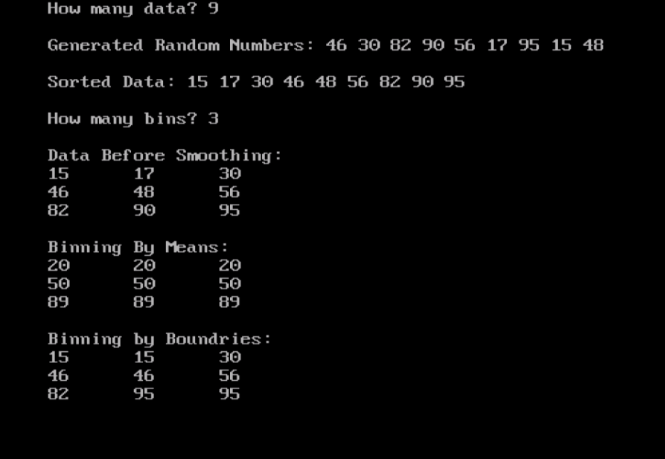
}
Output:

Practical : 7
Aim: To Study APRIORY Algorithm.
The Apriori Algorithm Basic:
The Apriori Algorithm is an influential algorithm for mining frequent item sets for Boolean association rules.

Key Concepts:
• Frequent Itemsets: The sets of item which has minimum support (denoted by Li for ith- Item set).
• Apriori Property: Any subset of frequent itemset must be frequent.
• Join Operation: To find Lk , a set of candidate k-itemsets is generated by joining Lk-1 with itself.

The Apriori Algorithm in a Nutshell
- Find the frequent itemsets: the sets of items that have minimum support
  - A subset of a frequent itemset must also be a frequent itemset
i.e., if {AB} is a frequent itemset, both {A} and {B} should be a frequent itemset
  - Iteratively find frequent itemsets with cardinality from 1 to k (k-itemset)
- Use the frequent itemsets to generate association rules.

The Apriori Algorithm:
• Join Step: Ck is generated by joining Lk-1with itself
• Prune Step: Any (k-1)-itemset that is not frequent cannot be a subset of a frequent k-itemset
• Pseudo-code:
Ck: Candidate itemset of size k
Lk: frequent itemset of size k
L1 = {frequent items};
for (k = 1; Lk !=∅; k++) do begin
Ck+1 = candidates generated from Lk;
for each transaction t in database
do Increment the count of all candidates in Ck+1 that are contained in t L_{k}+1 = candidates in C_{k}+1 with min_support
end
return U_{k} L_{k};
The Apriori Algorithm: Example

TID | List of Items
T100 | I1, I2, I5
T100 | I2, I4
T100 | I2, I3
T100 | I1, I2, I4
T100 | I1, I3
T100 | I2, I3
T100 | I1, I3
T100 | I1, I2 ,I3, I5
T100 | I1, I2, I3

Consider a database, D , consisting of 9 transactions.
Suppose min. support count required is 2 (i.e. min_sup = 2/9 =22 %)
Let minimum confidence required is 70%.
We have to first find out the frequent itemset using Apriori algorithm.
Then, Association rules will be generated using min. support & min. confidence

Step 1: Generating 1-itemset Frequent Pattern

- The set of frequent 1-itemsets, L1, consists of the candidate 1- itemsets satisfying minimum support.

- In the first iteration of the algorithm, each item is a member of the set of candidate.

Step 2: Generating 2-itemset Frequent Pattern

To discover the set of frequent 2-itemsets, L2 , the algorithm uses L1 Join L1 to generate a candidate set of 2-itemsets, C2.
- Next, the transactions in D are scanned and the support count for each candidate itemset in C2 is accumulated (as shown in the middle table).
- The set of frequent 2-itemsets, L2 , is then determined, consisting of those candidate 2-itemsets in C2 having minimum support.
- Note: We haven’t used Apriori Property yet

Step 3: Generating 3-itemset Frequent Pattern
The generation of the set of candidate 3-itemsets, C3 , involves use of the Apriori Property.
- In order to find C3, we compute L2 Join L2.
- C3 = L2 Join L2 = {{I1, I2, I3}, {I1, I2, I5}, {I1, I3, I5}, {I2, I3, I4}, {I2, I3, I5}, {I2, I4, I5}}.

- Now, Join step is complete and Prune step will be used to reduce the size of C3. Prune step helps to avoid heavy computation due to large Ck.
Based on the Apriori property that all subsets of a frequent itemset must also be frequent, we can determine that four latter candidates cannot possibly be frequent. How
- For example , lets take {I1, I2, I3}. The 2-item subsets of it are {I1, I2}, {I1, I3} & {I2, I3}. Since all 2-item subsets of {I1, I2, I3} are members of L2, We will keep {I1, I2, I3} in C3.
- Lets take another example of {I2, I3, I5} which shows how the pruning is performed. The 2-item subsets are {I2, I3}, {I2, I5} & {I3,I5}.
- BUT, {I3, I5} is not a member of L2 and hence it is not frequent violating Apriori Property. Thus We will have to remove {I2, I3, I5} from C3.
- Therefore, C3 = {{I1, I2, I3}, {I1, I2, I5}} after checking for all members of result of Join operation for Pruning.
- Now, the transactions in D are scanned in order to determine L3, consisting of those candidates 3-itemsets in C3 having minimum support

Step 4: Generating 4-itemset Frequent Pattern
The algorithm uses L3 Join L3 to generate a candidate set of 4-itemsets, C4. Although the join results in {{I1, I2, I3, I5}}, this itemset is pruned since its subset {{I2, I3, I5}} is not frequent.
- Thus, C4 = φ , and algorithm terminates, having found all of the frequent items. This completes our Apriori Algorithm.
- What’s Next ?
These frequent itemsets will be used to generate strong association rules ( where strong association rules satisfy both minimum support & minimum confidence).
Step 5: Generating Association Rules from Frequent Itemsets.
Procedure:

- For each frequent itemset “l”, generate all nonempty subsets of l.

- For every nonempty subset s of l, output the rule “s Æ (l-s)” if support_count(l) / support_count(s) >= min_conf where min_conf is minimum confidence threshold

Back To Example:

We had L = {{I1}, {I2}, {I3}, {I4}, {I5}, {I1,I2}, {I1,I3}, {I1,I5}, {I2,I3}, {I2,I4}, {I2,I5}, {I1,I2,I3}, {I1,I2,I5}}.

Let’s take l = {I1, I2, I5}. Its all nonempty subsets are {I1,I2}, {I1,I5}, {I2,I5}, {I1}, {I2}, {I5}.

Let minimum confidence threshold is, say 70%.
• The resulting association rules are shown below, each listed with its confidence.

  - R1: I1 ^ I2 Æ I5
• Confidence = sc{I1,I2,I5}/sc{I1,I2} = 2/4 = 50%
• R1 is Rejected.

  - R2: I1 ^ I5 Æ I2
• Confidence = sc{I1,I2,I5}/sc{I1,I5} = 2/2 = 100%
• R2 is Selected. – R3: I2 ^ I5 Æ I1
• Confidence = sc{I1,I2,I5}/sc{I2,I5} = 2/2 = 100%
• R3 is Selected.

– R4: I1 Æ I2 ^ I5

• Confidence = sc{I1,I2,I5}/sc{I1} = 2/6 = 33%
• R4 is Rejected. – R5: I2 Æ I1 ^ I5
• Confidence = sc{I1,I2,I5}/{I2} = 2/7 = 29%
• R5 is Rejected. – R6: I5 Æ I1 ^ I2
• Confidence = sc{I1,I2,I5}/ {I5} = 2/2 = 100%
• R6 is Selected.

In this way,We have found three strong association rules.
Methods to Improve Apriori’s Efficiency
• Hash-based itemset counting: A k-itemset whose corresponding hashing bucket count is below the threshold cannot be frequent.
• Transaction reduction: A transaction that does not contain any frequent k-itemset is useless in subsequent scans.

• Partitioning: Any itemset that is potentially frequent in DB must be frequent in at least one of the partitions of DB.

• Sampling: mining on a subset of given data, lower support threshold + a method to determine the completeness.

• Dynamic itemset counting: add new candidate itemsets only when all of their subsets are estimated to be frequent.
Mining Frequent Patterns Without Candidate Generation
- Compress a large database into a compact,Frequent Pattern tree (FP-tree) structure

  - highly condensed, but complete for frequent pattern mining

– avoid costly database scans
- Develop an efficient, FP-tree-based frequent pattern mining method

  - A divide-and-conquer methodology: decompose mining tasks into smaller ones

– Avoid candidate generation: sub-database test only

Practical : 8
Aim : Implementation Of Naive Bayesian Classifiers In Java.

Introduction
The goals of this document are first to give a short overview to naive bayesian classifiers and second to document an implementation of naive bayesian classifiers in the programing language Java using XML for the data input.
Bayesian Learning
Other learning algorithms eliminate those hypotheses, which are not consistent to a training example. Whereas the Bayesian Learning just reduces the probability of an inconsistent hypothesis. This gives the Bayesian Learning a bigger flexibility. The Bayesian Learning Algorithms combine training data with a priori knowledge to get the a posteriori probability of an hypothesis. So it is possible to figure out the most probable hypothesis according to the training data. The basis for all Bayesian Learning Algorithms is the Bayes Rule.
P(h) = prior probability of hypothesis h
P(D) = prior probability of training data D
P(h|D) = probability of h given D
P(D|h) = probability of D given h

Naive Bayes Algorithm
One of these algorithms is the Naive Bayes Algorithm, which uses Naive Bayesian Classifiers. Up to now we wondered which hypothesis is the most probable for a given dataset resp. a new instance.
But the question what Naive Bayesian Classifiers are about is which classification is the most probable for this new instance if we have a look at the training data.
For example an instance of an patient = (age,sex,weight) could be (45,male,120kg). An Naive Bayes System could calculate values for the following two classifications “cardiac insufficiency” and “no cardiac insufficiency” according to the available training data. Then the classifier with the

biggest value rules the hypothesis. Whereby the conditional independence of the attributes of the instances is required for the use of Naive Bayesian Classifiers.
How does it look brought into a formula?

X be a set of instances xi = (a1,a2,…,an)
V be a set of classifications vj

Naive Bayes assumption:

This leads to the following algorithm: Naive_Bayes_Learn (examples)

for each target value vj

estimate P(vj)
for each attribute value ai of each attribute a estimate P(ai | vj )

Classify_New_Instance (x)

The Implementation

When the design was started for little application, three decisions were made: 1. the application should be useable for different kinds of training data, whereby only two targets (classifications) are allowed. 2. It should use a GUI for the communication with the user. 3. the application should be platform independent. That‟s why we chose Java as programming language for this project and XML for the representation of the training data.

The Java Classes

NaiveBayesApplication:
This class is responsible for the GUI and inherits from the javax.swing.JFrame class. It has the following important attributes:
- NaiveBayesLearner learner
- String domain (stores the name of the training data domain)
- Vector stringkeys (in this vector keywords were stored according to the instance requested by the user)

Thera are some other attributes which are only important for the GUI and the interaction with the user, but not for the algorithm.

The methods are:

main() (instantiates an object of NaiveBayesApplication)
- loadTrainingData() (loads an XML-training data file with a DOMParser, calls the method getGUIPanelFromXML(), instantiates the attribut learner and calls its method learn() )
- getGUIPanelFromXML(Node,Node) (creates the GUI out of two Node objects according to the org.w3c.dom)
- calculate() (calls the calculate(stringkeys) method of the attribute learner with the vector stringkeys as parameter and actualizes the result on the screen from a Panel which is delivered by the called method)
- createActions() (creates AbstractActions objects, which are triggered when the user clicks the according buttons)

NaiveBayesLearner:
This class actually includes the algorithm. It has the following attributes:
- int numberofdatasets (used to store the number of training data examples)
- int numberofyes (used to store the number of training data examples which have positive result)
- int numberofno (used to store the number of training data examples which have negative result)
- String domain (stores the name of the training data domain)
- Hashtable attributevalues (This hashtable is filled with AttributeValue objects according to all possible values that the different attributes of the current training data can have. String objects where used as keys. AttributeValue objects count.
Methods :

- learn(Node,Node) (fills up the attributevalues hashtable with AttributeValues objects and brings those to count their number of appeareances depending on the result.)
- calculate(Vector) (calculates, according to the Strings in the given Vector, the two classifiers, for the according AttributeValue objects, and the hypothesis. These classifiers and the hypothesis were put into a Panel and returned)

The typical estimation of P(ai|vj):
Where
n: examples with v=v;
p is prior estimate for P(ai|vj)
nc: examples with a=ai,
m is an empirical smoothing factor depending on the training data.

Since I liked to make the application useable for different kinds of training data, I chose the following estimation, which is sufficient, if the number of training datasets is not very small.
AttributeValue:

This class has these attributes:
- String name (stores the String which describes this AttributeValue object)
- int counteryes (stores the number of appearances of this AttributeValue object on positve results)
- int counterno (stores the number of apperances of this AttributeValue object on negative results)

and these methods:

- countyes() (increments counteryes)
- countno() (increments counterno)
- as well as get methods for counteryes and counterno

Class diagram

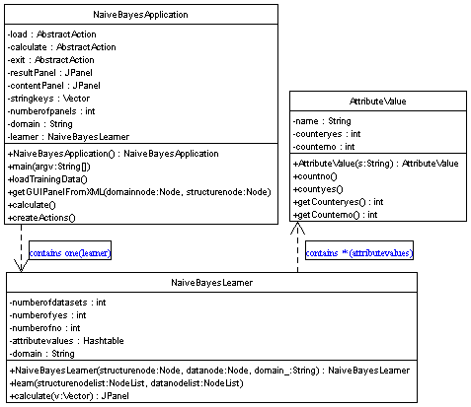
Sequence diagram
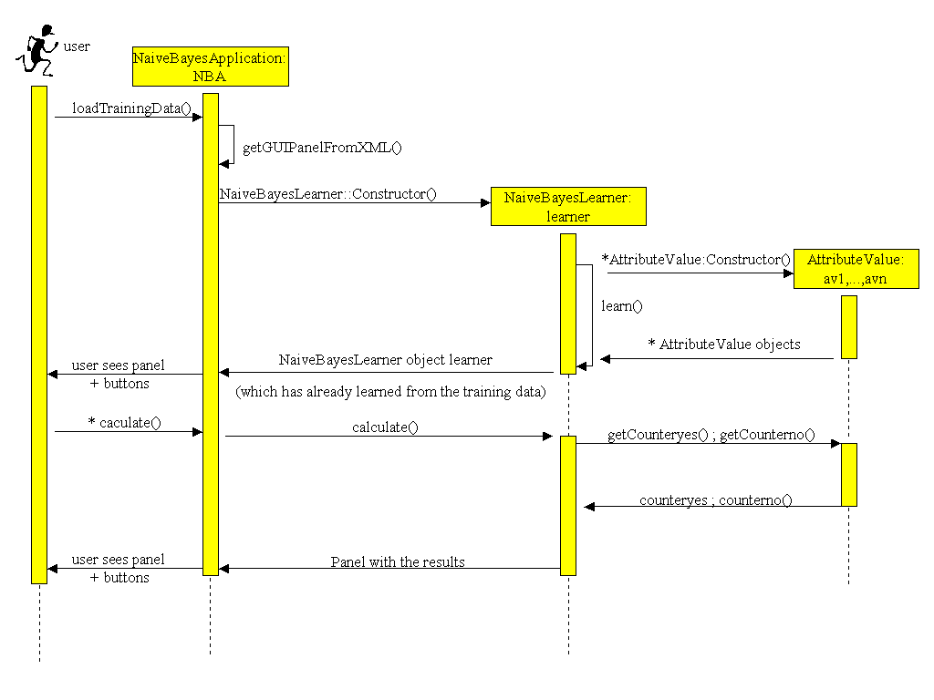
Screenshot from the application

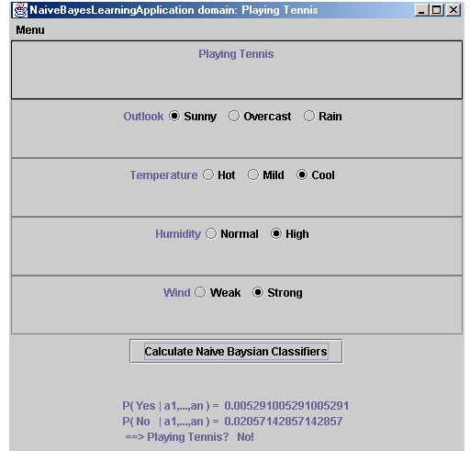

Calculate, using the Naive Bayes classifier, the two most probable scenarios – playing tennis or not – in the following situation:
Outlook = Sunny
Temperature = Cool
Humidity = High
Wind = Strong
The included program uses the Naive Bayes classifier to determine if the given situation results in playing tennis or not.
A screenshot of the execution of this program is displayed to the right. The program displays the calculation results on-screen, which are summarized below. First, the program searches for similar training examples. It will try to determine the probability of each possible outcome based on prior knowledge. In this case, there are two possible outcomes:
- PlayTennis = Yes;
- PlayTennis = No.
For each outcome, the algorithm „compares‟ the number of features that match the given situation. The outcome of the given scenario is Yes, where:
- 9 of the 14 examples give the outcome Yes;

- Of which 2 of those 9 return Sunny;
- Of which 3 of those 9 return Cool;
- Of which 3 of those 9 return High;
- Of which 3 of those 9 return Strong.
Calculating the sum over all ratios gives the probability for outcome Yes, denoted: P (y)
P(y) = (9/14) *(2/9)*(3/9)*(3/9)*(3/9) = 0.0053
Likewise, we calculate the probability for outcome No, denoted: P (n)
P(n)= (5/14)*(3/5)*(1/5)*(4/5)*(3/5) =0.0206
Because the probability for outcome P(n) (PlayTennis = No) is greater than P(y) (PlayTennis = Yes), we may conclude that – according to Naive Bayes – we most likely will not want to play tennis in the given scenario, and thus that the algorithm returns No.
There are three classes left, which fulfil control tasks.
MyRadioButtonListener:
This class is an inner class of the NaiveBayesApplication class, it implements the java.awt.event.ActionListener interface. There is instanciated one listener for every RadioButton. The task of ths listeners is to keep the stringkeys vector of the NaiveBayesApplication consistent to the selected RadioButtons.
WindowCloser:
This class implements the java.awt.event.WindowListener interface. The instanced object is responsible for shutting down the application when the user closes the application window.
XMLFileFilter:
This class inherits from the javax.swing.filechooser.FileFilter class. The instanced object is responsible that only XML-files are shown, when the user loads new training data.

How to run the program
To get this application running you need the jdk1.3 or higher and the package which provides the DOMparser . You must add the path of this package to your Classpath variable, then the application should work.

Practical : 9
Aim : To Study And Implement K- Means Clustering In Java.

K-means is one of the simplest unsupervised learning algorithms that solve the well known clustering problem. The procedure follows a simple and easy way to classify a given data set through a certain number of clusters (assume k clusters) fixed a priori. The main idea is to define k centroids, one for each cluster. These centroids shoud be placed in a cunning way because of different location causes different result. So, the better choice is to place them as much as possible far away from each other. The next step is to take each point belonging to a given data set and associate it to the nearest centroid. When no point is pending, the first step is completed and an early groupage is done. At this point we need to re-calculate k new centroids as barycenters of the clusters resulting from the previous step. After we have these k new centroids, a new binding has to be done between the same data set points and the nearest new centroid. A loop has been generated. As a result of this loop we may notice that the k centroids change their location step by step until no more changes are done. In other words centroids do not move any more.

k-means algorithm:
- Initialize the center of the clusters
- Attribute the closest cluster to each data point
- Set the position of each cluster to the mean of all data points belonging to that cluster.
- Repeat steps 2-3 until convergence.
- Stop.

Considering an example :
Subject | A | B
1 | 1.0 | 1.0
2 | 1.5 | 2.0
3 | 3.0 | 4.0
4 | 5.0 | 7.0
5 | 3.5 | 5.0
6 | 4.5 | 5.0
7 | 3.5 | 4.5

-Here, Initialize cluster centroid,

 | Individual | Mean Vector (centroid)
Group 1 | 1 | (1.0,1.0)
Group 2 | 4 | (5.0,7.0)

Find Euclidean distance for each data point and assign closest cluster,

Data Point | Distance with cluster 1 centroid | Distance with cluster 2 centroid | Closest cluster
(1,1) | 0.0 | 7.211 | 1
(1.5,2) | 1.11 | 6.10 | 1
(3,4) | 3.60 | 3.60 | 1
(5,7) | 6.40 | 0.0 | 2
(3.5,5) | 3.90 | 2.5 | 2
(4.5,5) | 4.61 | 1.12 | 2
(3.5,4.5) | 3.54 | 0.71 | 2

New centroid for each cluster,

 | Individual | Mean Vector (centroid)
Cluster 1 | 1,2,3 | (1.8,2.3)
Cluster 2 | 4,5,6,7 | (4.125,5.375)

But we cannot sure that each individual has been assigned to the right cluster so same process step 2-3 repeated. So, find distance….

Data Point | Distance with cluster 1 centroid | Distance with cluster 2 centroid | Closest cluster
(1,1) | 1.57 | 5.38 | 1
(1.5,2) | 0.47 | 4.28 | 1
(3,4) | 2.04 | 1.78 | 2
(5,7) | 5.64 | 1.85 | 2
(3.5,5) | 3.15 | 0.73 | 2
(4.5,5) | 3.77 | 0.53 | 2
(3.5,4.5) | 2.74 | 1.07 | 2

So, New centroid for each cluster,
 | Individual | Mean Vector (centroid)
Cluster 1 | 1,2 | (1.25,1.5)
Cluster 2 | 3,4,5,6,7 | (3.9,5.1)

The iterative relocation would now continue from this new partition until no more relocations occur. However , in this example each individual is now nearer its own cluster mean than that of the other cluster and the iteration stops, choosing the latest partitioning as the final cluster solution.
Also , it is possible that the k-mean algorithm won’t find a final solution ,In this case it would be a good idea to consider stopping the algorithm after a pre-chosen maximum of iterations.
Java File :

import java.util.ArrayList;
public class KMeans_Ex4a
{
private static final int NUM_CLUSTERS = 2; // Total clusters.
private static final int TOTAL_DATA = 7; // Total data points.

private static final double SAMPLES[][] = new double[][] {{1.0, 1.0},
{1.5, 2.0},
{3.0, 4.0},
{5.0, 7.0},
{3.5, 5.0},
{4.5, 5.0},
{3.5, 4.5}};

private static ArrayList<Data> dataSet = new ArrayList<Data>();
private static ArrayList<Centroid> centroids = new ArrayList<Centroid>();

private static void initialize()

{
System.out.println("Centroids initialized at:");
centroids.add(new Centroid(1.0, 1.0)); // lowest set.
centroids.add(new Centroid(5.0, 7.0)); // highest set.
System.out.println(" (" + centroids.get(0).X() + ", " + centroids.get(0).Y() + ")");
System.out.println(" (" + centroids.get(1).X() + ", " + centroids.get(1).Y() + ")");
System.out.print("\n");
return;
}

private static void kMeanCluster()
{
final double bigNumber = Math.pow(10, 10); // some big number that's sure to be larger than our data range.
double minimum = bigNumber; // The minimum value to beat.
double distance = 0.0; // The current minimum value.
int sampleNumber = 0;
int cluster = 0;
boolean isStillMoving = true;
Data newData = null;

// Add in new data, one at a time, recalculating centroids with each new one.
while(dataSet.size() < TOTAL_DATA)
{
newData = new Data(SAMPLES[sampleNumber][0], SAMPLES[sampleNumber][1]);
dataSet.add(newData);
minimum = bigNumber;
for(int i = 0; i < NUM_CLUSTERS; i++)
{
distance = dist(newData, centroids.get(i));
if(distance < minimum){
minimum = distance;
cluster = i;
}
}
newData.cluster(cluster);

// calculate new centroids.

for(int i = 0; i < NUM_CLUSTERS; i++)
{
double totalX = 0;
double totalY = 0;
int totalInCluster = 0;
for(int j = 0; j < dataSet.size(); j++)
{
if(dataSet.get(j).cluster() == i){
totalX += dataSet.get(j).X();
totalY += dataSet.get(j).Y();
totalInCluster++;
}
}
if(totalInCluster > 0){
centroids.get(i).X(totalX / (double)totalInCluster);
centroids.get(i).Y(totalY / (double)totalInCluster);
}

}

sampleNumber++;
}

System.out.println("now cluster 0 include");
for(int j = 0; j < dataSet.size(); j++)
{

if(dataSet.get(j).cluster() == 0){
System.out.println(" (" + dataSet.get(j).X() + ", " + dataSet.get(j).Y() + ")");
}
}

System.out.println("now cluster 1 include");
for(int j = 0; j < dataSet.size(); j++)

{
if(dataSet.get(j).cluster() == 1){
System.out.println(" (" + dataSet.get(j).X() + ", " + dataSet.get(j).Y() + ")");
}
}

// Now, keep shifting centroids until equilibrium occurs.
while(isStillMoving)
{
// calculate new centroids.
System.out.println("New centroid: ");
for(int i = 0; i < NUM_CLUSTERS; i++)
{
double totalX = 0;
double totalY = 0;
int totalInCluster = 0;
for(int j = 0; j < dataSet.size(); j++)
{
if(dataSet.get(j).cluster() == i){
totalX += dataSet.get(j).X();
totalY += dataSet.get(j).Y();
totalInCluster++;
}
}
if(totalInCluster > 0){
centroids.get(i).X(totalX / (double)totalInCluster);
centroids.get(i).Y(totalY / (double)totalInCluster);
}

System.out.println(" (" + centroids.get(i).X() + ", " + centroids.get(i).Y() + ")");
}
// Assign all data to the new centroids
isStillMoving = false;

for(int i = 0; i < dataSet.size(); i++)
{

Data tempData = dataSet.get(i);
minimum = bigNumber;
for(int j = 0; j < NUM_CLUSTERS; j++)
{
distance = dist(tempData, centroids.get(j));
//System.out.println("i= "+i+"distance= "+distance+"minimum="+minimum);
if(distance < minimum){
minimum = distance;
cluster = j;
}
}

tempData.cluster(cluster);

if(tempData.cluster() != cluster){
tempData.cluster(cluster);
isStillMoving = true;
}
}

for(int i = 0; i < NUM_CLUSTERS; i++)
{
double totalX = 0;
double totalY = 0;
int totalInCluster = 0;
for(int j = 0; j < dataSet.size(); j++)
{
if(dataSet.get(j).cluster() == i){
totalX += dataSet.get(j).X();
totalY += dataSet.get(j).Y();
totalInCluster++;
}
}
if(totalInCluster > 0){
centroids.get(i).X(totalX / (double)totalInCluster);
centroids.get(i).Y(totalY / (double)totalInCluster);
}

//System.out.println("2-centroid x= "+centroids.get(i).X()+"Y= "+centroids.get(i).Y());
}
}
return;
}

/**
* // Calculate Euclidean distance.
* @param d - Data object.
* @param c - Centroid object.
* @return - double value.
*/
private static double dist(Data d, Centroid c)
{
return Math.sqrt(Math.pow((c.Y() - d.Y()), 2) + Math.pow((c.X() - d.X()), 2));
}

private static class Data
{
private double mX = 0;
private double mY = 0;
private int mCluster = 0;

public Data()
{
return;
}

public Data(double x, double y)
{
this.X(x);
this.Y(y);
return;
}

public void X(double x)
{

this.mX = x;
return;
}
public double X()
{
return this.mX;
}
public void Y(double y)
{
this.mY = y;
return;
}

public double Y()
{
return this.mY;
}

public void cluster(int clusterNumber)
{
this.mCluster = clusterNumber;
return;
}

public int cluster()
{
return this.mCluster;
}
}

private static class Centroid
{
private double mX = 0.0;
private double mY = 0.0;

public Centroid()
{

return;
}

public Centroid(double newX, double newY)
{
this.mX = newX;
this.mY = newY;
return;
}

public void X(double newX)
{
this.mX = newX;
return;
}

public double X()
{
return this.mX;
}

public void Y(double newY)
{
this.mY = newY;
return;
}

public double Y()
{
return this.mY;
}
}

public static void main(String[] args)
{
initialize();

kMeanCluster();

// Print out clustering results.
for(int i = 0; i < NUM_CLUSTERS; i++)
{
System.out.println("Cluster " + i + " includes:");
for(int j = 0; j < TOTAL_DATA; j++)
{
if(dataSet.get(j).cluster() == i){
System.out.println(" (" + dataSet.get(j).X() + ", " + dataSet.get(j).Y() + ")");
}
} // j
System.out.println();
} // i

// Print out centroid results.
System.out.println("Centroids finalized at:");
for(int i = 0; i < NUM_CLUSTERS; i++)
{
System.out.println(" (" + centroids.get(i).X() + ", " + centroids.get(i).Y()+" ) ");
}
System.out.print("\n");
return;
}
}

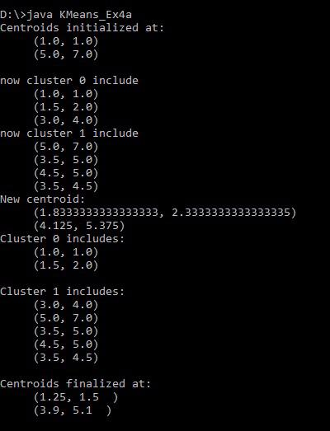
OUTPUT:

Practical : 10

Aim : Perform Different Data Mining Activities Using Weka Explorer Tool (Open Source Data Mining Tool).
Weka:
Data mining isn't solely the domain of big companies and expensive software. In fact, there's a piece of software that does almost all the same things as these expensive pieces of software the software is called WEKA.WEKA is the product of the University of Waikato (New Zealand) and was first implemented in its modern form in 1997. It uses the GNU General Public License (GPL). The software is written in the Java™ language and contains a GUI for interacting with data files and producing visual results (think tables and curves). It also has a general API, so you can embed WEKA, like any other library, in your own applications to such things as automated server-side data-mining tasks.
At this point, please go ahead and install WEKA. It's Java-based, so if you don't have a JRE installed on your computer, download the WEKA version that contains the JRE, as well.
Figure 1. WEKA startup screen

When you start WEKA, the GUI chooser pops up and lets you choose four ways to work with WEKA and your data. For all the examples in this article series, we will choose only the Explorer option. This option is more than sufficient for everything we need to do in these articles.

Figure 2. WEKA Explorer
Step by step instructions
During installation, the ARFF files should have been associated with Weka. In this case, it is highly recommended to locate and double click on the file dud.arff, and to skip the following three points.
- • In the starting interface of Weka, click on the button Explorer.
      - • In the Preprocess tab, click on the button Open File. In the file selection interface, select the file weather.arff.
Once the data is loaded, WEKA recognizes attributes that are shown in the ‘Attribute’ window.
Left panel of ‘Preprocess’ window shows the list of recognized attributes:
No. is a number that identifies the order of the attribute as they are in data file,
Selection tick boxes allow you to select the attributes for working relation,
Name is a name of an attribute as it was declared in the data file.
The ‘Current relation’ box above ‘Attribute’ box displays the base relation (table) name and the current working relation (which are initially the same) - “weather”, the number of instances – 14 and the number of attributes - 5. During the scan of the data, WEKA computes some basic statistics on each attribute. The following statistics are shown in ‘Selected attribute’ box on the right panel of ‘Preprocess’ window:
Name is the name of an attribute,
Type is most commonly Nominal or Numeric, and
Missing is the number (percentage) of instances in the data for which this attribute is
unspecified,
Distinct is the number of different values that the data contains for this attribute, and
Unique is the number (percentage) of instances in the data having a value for this attribute that no other instances have.
11 An attribute can be deleted from the ‘Attributes’ window. Highlight an attribute you would like to delete and hit Delete button on your keyboard.
By clicking on an attribute, you can see the basic statistics on that attribute. The frequency for each attribute value is shown for categorical attributes. Min, max, mean, standard deviation
(StdDev) is shown for continuous attributes.
Click on attribute Outlook in the ‘Attribute’ window.
Outlook is nominal. Therefore, you can see the following frequency statistics for this attribute in the ‘Selected attributes’ window:
Missing = 0 means that the attribute is specified for all instances (no missing values),
Distinct = 3 means that Outlook has three different values: sunny, overcast, rainy, and
Unique = 0 means that other instances do not have the same value as Outlook has.
Just below these values there is a table displaying count of instances of the attribute Outlook.
As you can see, there are three values: sunny with 5 instances, overcast with 4 instances, and rainy with 5 instances. These numbers match the numbers of instances in the base relation and table “weather.xls”.
Lets take a look at the attribute Temperature.

Setting Filters
Pre-processing tools in WEKA are called “filters”. WEKA contains filters for discretization, normalization, resampling, attribute selection, transformation and combination of attributes. Some techniques, such as association rule mining, can only be performed on categorical data. This requires performing discretization on numeric or continuous attributes.
For classification example you do not need to transform the data. For you practice, suppose you need to perform a test on categorical data. There are two attributes that need to be converted: ‘temperature’ and ‘humidity’. In other words, you will keep all of the values for these attributes in the data.
This means you can discretize by removing the keyword "numeric" as the type for the ‘temperature’ attribute and replace it with the set of “nominal” values. You can do this by applying a filter.
In ‘Filters’ window, click on the ‘Choose’ button.
This will show pull-down menu with a list of available filters. Select Supervised AttributeDiscretize and click on ‘Apply’ button. The filter will convert Numeric values into Nominal.

When filter is chosen, the fields in the window changes to reflect available options.
Building “Classifiers”
Once you have your data set loaded, all the tabs are available to you. Click on the ‘Classify’ tab.
‘Classify’ window comes up on the screen.
Choosing a Classifier
Click on ‘Choose’ button in the ‘Classifier’ box just below the tabs and select C4.5 classifier WEKA Classifiers Trees J48.
Setting Test Options
Before you run the classification algorithm, you need to set test options. Set test options in the ‘Test options’ box. The test options that available to you are :
1. Use training set. Evaluates the classifier on haw well it predicts the class of the instances it was trained on.
2. Supplied test set. Evaluates the classifier on how well it predicts the class of a set of instances loaded from a file. Clicking on the ‘Set…’ button brings up a dialog allowing you to choose the file to test on.
3. Cross-validation. Evaluates the classifier by cross-validation, using the number of folds that are entered in the ‘Folds’ text field.
4. Percentage split. Evaluates the classifier on how well it predicts a certain percentage of the data, which is held out for testing. The amount of data held out depends on the value entered in the ‘%’ field.
In this exercise you will evaluate classifier based on how well it predicts 66% of the tested data. Check ‘Percentage split’ radio-button and keep it as default 66%. Click on ‘More options…’ button.
Identify what is included into the output. In the ‘Classifier evaluation options’ make sure that the following options are checked:
1. Output model. The output is the classification model on the full training set, so that it can be viewed, visualized, etc.
2. Output per-class stats. The precision/recall and true/false statistics for each class output.
3. Output confusion matrix. The confusion matrix of the classifier’s predictions is included in the output.
4. Store predictions for visualization. The classifier’s predictions are remembered so that they can be visualized.
5. Set ‘Random seed for Xval / % Split’ to 1. This specifies the random seed used when randomizing the data before it is divided up for evaluation purposes.
When training set is complete, the ‘Classifier’ output area on the right panel of ‘Classify’ window is filled with text describing the results of training and testing. A new entry appears in the ‘Result list’ box on the left panel of ‘Classify’ window.
Analyzing Results :

Visualization of Results
After training a classifier, the result list adds an entry.
WEKA lets you to see a graphical representation of the classification tree. Right-click on the entry in ‘Result list’ for which you would like to visualize a tree. It invokes a menu containing the following items:
Select the item ‘Visualize tree’; a new window comes up to the screen displaying the tree.

Beyond Syllabus
Aim: Use of Keel Tools for data mining and analysis.
KEEL (Knowledge Extraction based on Evolutionary Learning) is an open source (GPLv3) Java software tool that can be used for a large number of different knowledge data discovery tasks. KEEL is developed to build and use different Data Mining models. The main features of KEEL are:
- It includes around 100 data preprocessing algorithms proposed in the specialized literature: data transformation, discretization, instance and feature selection, noise filtering and so forth
- It contains a large collection of evolutionary algorithms for predicting models, preprocessing methods (evolutionary feature and instance selection among others) and postprocessing procedures (evolutionary tuning of fuzzy rules). It also presents many state-of-the-art methods for different areas of data mining such as decision trees, fuzzy rule based systems or crisp rule learning.
- It has a statistical analysis library to analyze algorithms.
- It contains an user-friendly interface, oriented to the analysis of algorithms.
We can distinguish four parts in the graphic environment:
- Data Management: the Data Management part allows users to create new Datasets or to create some partitions from an existing one. Also, you can view information from Datasets of your own, with the only restriction that they must meet the Keel format. In addition, it is possible to edit and apply transformations to the existing Datasets.
Another important thing is that the Data Management part allows you to generate Datasets in the keel format from UCI files.
- Experiments: the Experiments part has the objective of designing the desired experiments using a graphical interface. Doubtless, this is the more innovative tool integrated in this tool. The objective is to use available datasets and algorithms to generate a directory structure with all the necessary files needed to run the designed experiments in the local computer selected by the user. Now, you can forget scripts and other parameter files that made arduous the design of an experiment, and begin to use the new windows based interface.
With this program, yon only need to select the input data (datasets), the algorithms you want to use and to make the opportune connections between them. Also it is possible to concatenate methods, insert statistical tests, etc ...
One of the tasks that was more simplified is probably the configuration of the parameters; everything can be done from a simple dialog without requirement of external configuration files.
This part of KEEL has two main objectives: on the one hand, you can use the software as a test and evaluation tool during the development of an algorithm. On the other hand, it is also a good option in order to compare new developments with standard algorithms already implemented and available in KEEL 2.0.
- Educational: the teaching part has the main objective of designing the desired experiments using a graphical interface and an on-line execution of those experiments, being posible to stop and resume them as you need. Also, you can see the results of those experiments into the environment.
However, this part has a reduced number of available methods and lacks of result method and statistical test
- Modules: This part includes new modules extending the functionalities of the KEEL software tool:
  - Imbalanced learning: A module specially designed for generating experiments with imbalanced data.
  - Non-Parametric Statistical Analysis: This module allows to easily analize the results of any experimental study, expresed in raw CSV format. To do so, it includes several well-known non-parametric statistical tests, ready to use.
  - Semi-supervised Learning: This module is devoted to the creation and design of experiments related to semi-supervised learning.
  - Multiple Instance Learning: The multiple instance learning module allows the user to create and prepare experiments for multi-instance Learning.
RUNNNING Jar file:
Jar GraphInterKeel.jar
Or right click GraphInterKeel.jar and open with java TM SE platform binary.

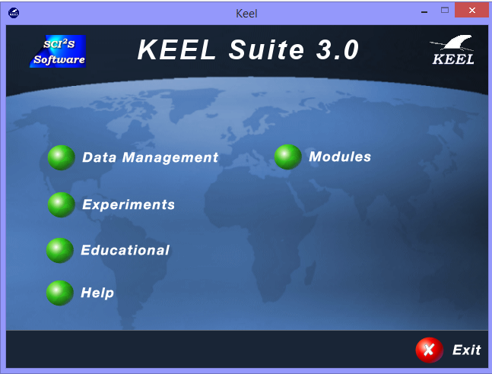

DATA MANAGEMENT
  - NEW DATASET
To create a new dataset, you must fill the following information:
- Relation: This is the name of the data set.
- Repeat the following steps until it is necessary:

  - Press the Add button and the following window will appear
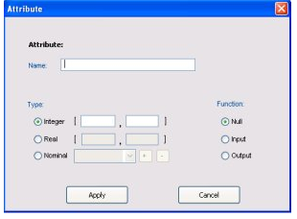

  - Introduce the attribute name.
  - Select the attribute's type. If the type is "Integer" or "Real" you must indicate the rank of values allowed. However, if the type is "Nominal", you must fill the list with the correct values.
  - You must specify the attribute function.
Using the 'Apply' button, the attribute defined is added to the DataSet. You can remove an attribute from the dataSet by selecting the desired one and pressing the 'Remove' button.

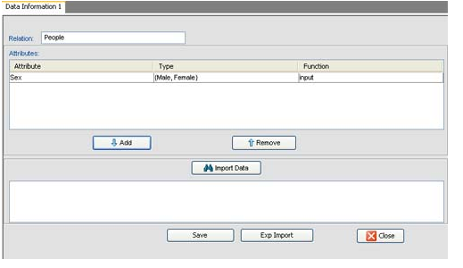
- Data insertion:
At this step, you must fill the content of the DataSet. There is two ways for doing it, typeing all the data (data must be separated by comas) or importing a file containing them.
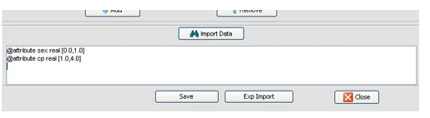
- Save:
If you have defined all the attributes and have filled the content of the DataSet, now you only need to Save the new DataSet to a file. At this stage, the content of the DataSet is validated according to the heading, and if an error is detected, a message is shown.
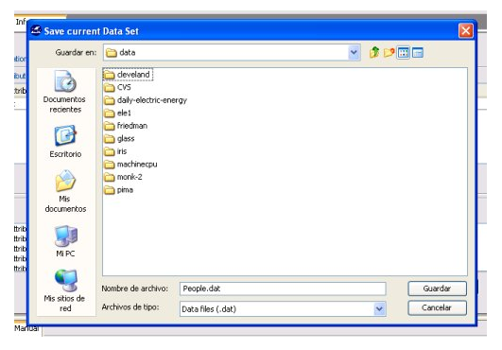
Other Function in data management:
2)View
3) Data import
4) Data Export
5) Partition
6) Edit
Experiment Design
File->new experiment and select dataset and next Select classification, clustering etc.
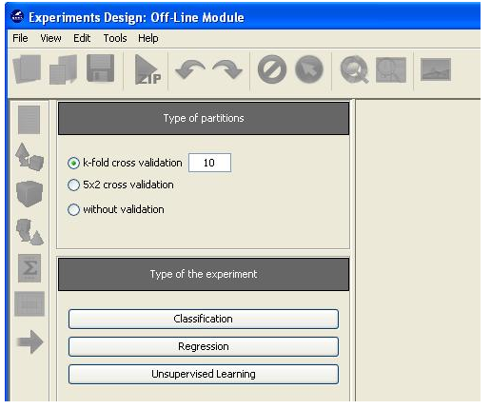
Selection of data set
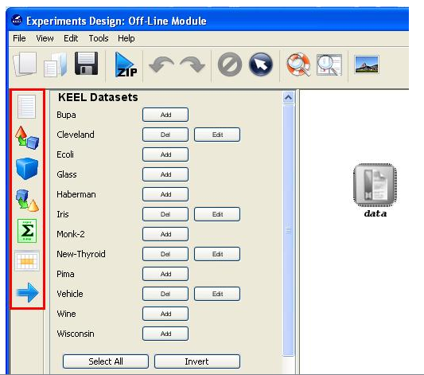
Drag and Drop data set and algorithm in design project and run it.
LAUNCHING RUN KEEL
Launching RunKeel

When the user designs an experiment, a .ZIP file will be obtained containing all the files needed to run the experiment in any computer that has a Java Virtual Machine installed. It is necessary to extract the content of the compressed file and then you will obtain a directory called "experiment" (as you had called your experiment). Inside it, there is a new directory called "scripts" in which you can launch the RunKEEL application by typing java -jar RunKeel.jar in a console. Then, the experiment begins to run.
When it finishes, the user will obtain at the command prompt the message "EXPERIMENT COMPLETED SUCCESSFULLY":

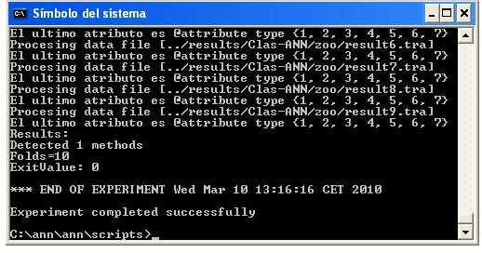

View results
Once the run of experiment has finished, the result files are can be found at the results\ directory.
Depending of the type of methods used in the experiment, the following directories and files will be available:
- Methods: For each combination of a method and a data set, there will be a directory, named <methodName>.<datasetName>. Inside, it is possible to find the output files of the method (generally, a training and a test output file for each partition, plus every additional output file defined by the method). For further reference, see the KEEL Reference Manual, http://sci2s.ugr.es/keel/development.php.
- Tests: For each test module employed, a new directory named with the name of the test will be available. This directory will contain the output files obtained as a result of the application of the test method.
On the other hand, note that the new data sets obtained as the result of the execution of a preprocessing method will be placed in the datasets\ directory of the experiment, to allow a further employment of them with linked methods in the same experiment.

